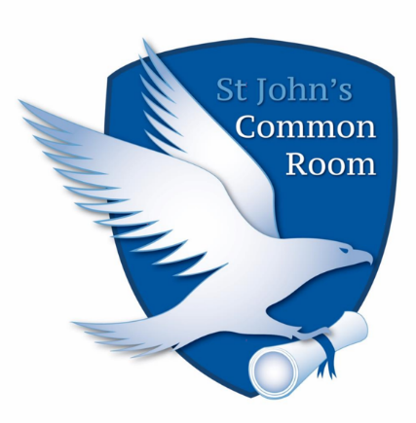

Checklist for Accessible Events

The SJCR organises social events and activities around College for its members. Some members of our community have disabilities and they need ‘reasonable adjustments’ to take part in activities. We aim to create an environment that is inclusive for all and to cater for all our members.
Point | Tick
Are there warnings of sudden flashing lights for people with epilepsy?
Smoke Machines- There needs to be a suitable warning before these are used. People with Asthma can be seriously affected by smoke.
Are there warnings of sudden loud noises which may occur? Sudden loud noises are painful to people with sensory impairments.
Does the venue have adequate toilet access? This is necessary for students with IBS and other conditions.
Are there quiet spaces where people can go if they are overwhelmed by the environment or need to take care of health needs?
Is the venue safe for people with visual impairments, i.e sudden steps or obstacles?
Suitable Seating- Are there places people can sit down?
Suitable Activities- Are there activities people can take part in who don’t want to drink alcohol or go to a place which is too rowdy?
Flexibility- Someone may need time out to manage a condition or to attend appointments.
Suitable Environment- Is the environment free from overwhelming triggers, such as loud noises and bright flashing lights?
Are the resources/powerpoint slides suitable for people with dyslexia/visual impairments?
Is the environment free from negative stereotypes which make persons with disabilities uncomfortable?

